Topics Covered:-

1. Print Hello World.
2. Print the String using Springboot.

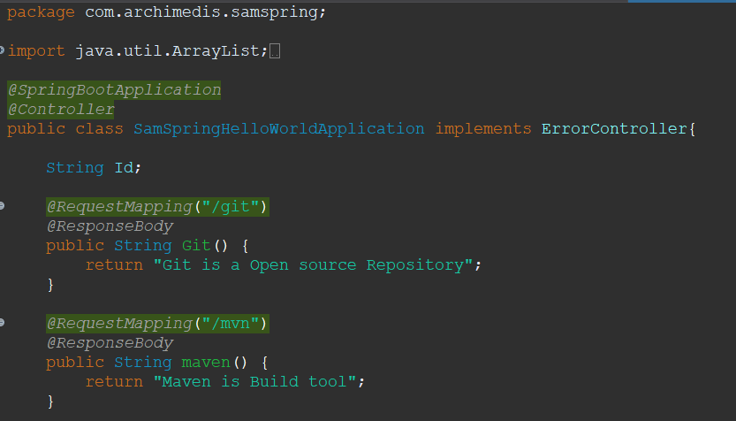

1. Customize the error page.

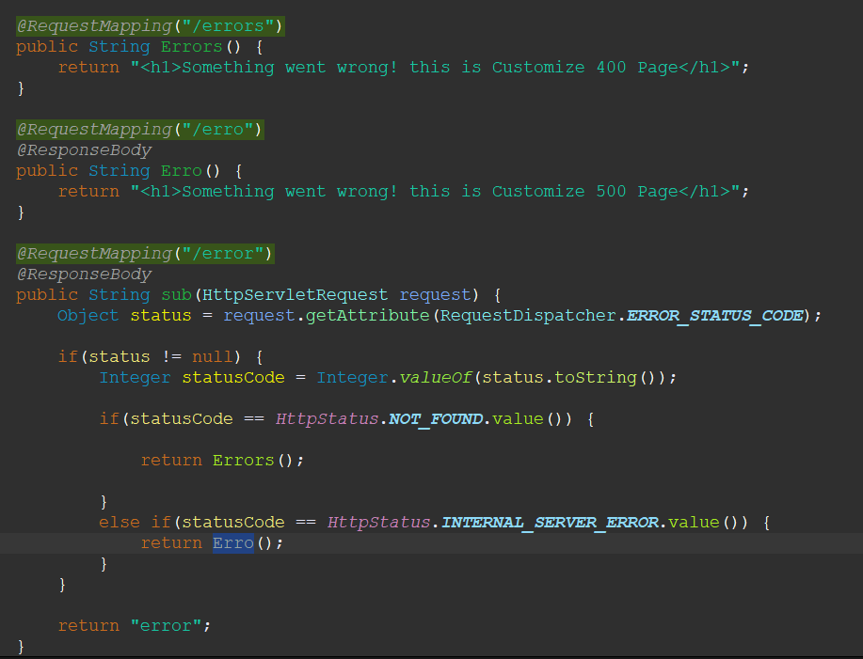

1. Print the JSON Element Using POJO Class.

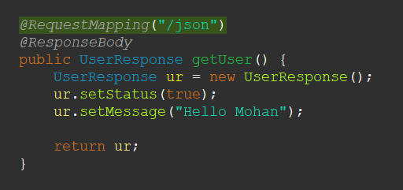

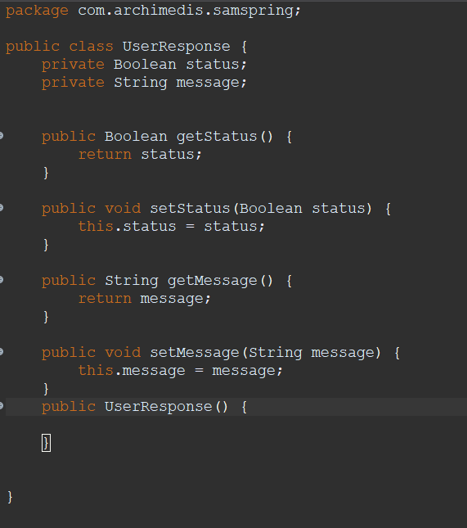

1. 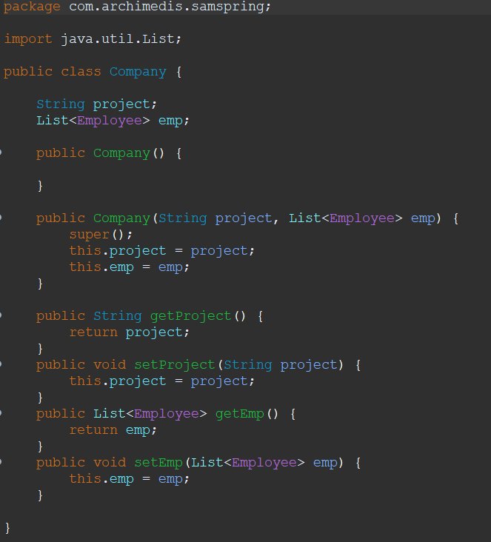Print the JSON Element Using Nested POJO Class. 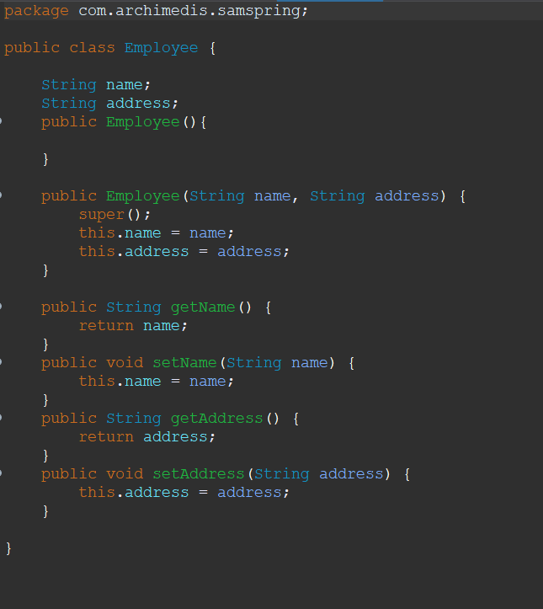

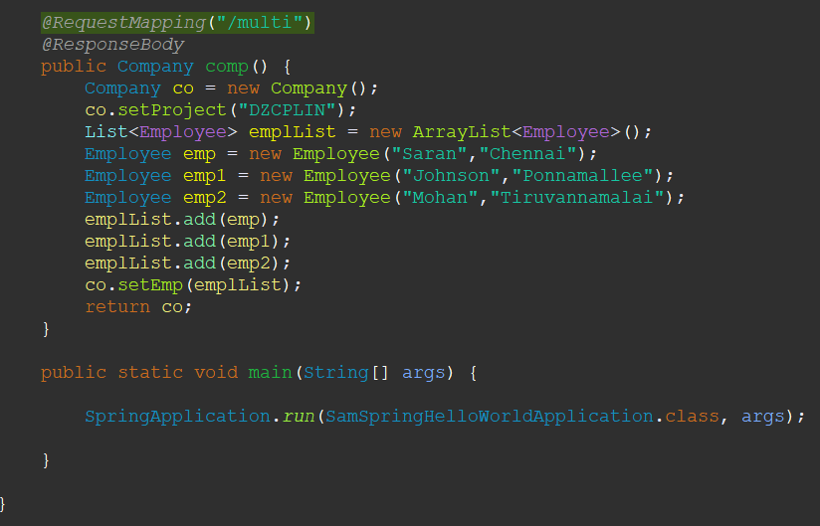

1. Thymleaf Configuration.

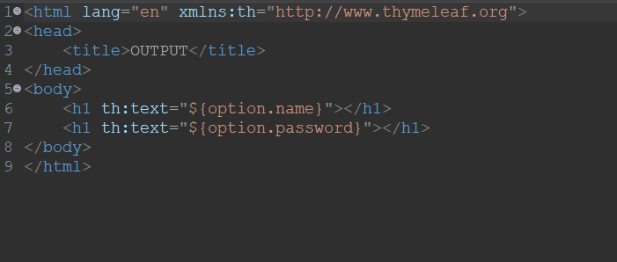

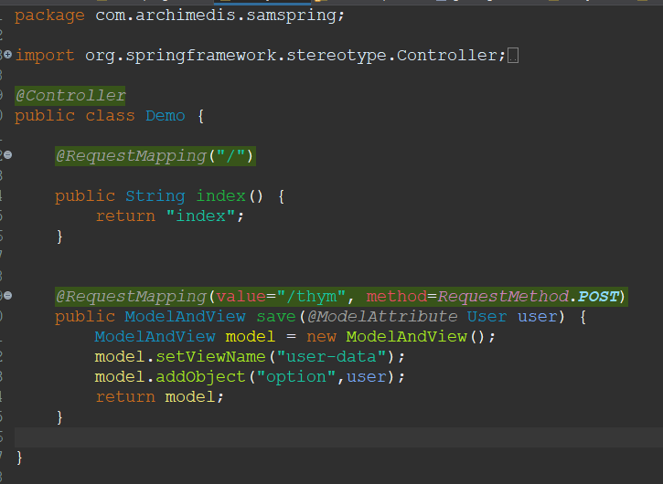

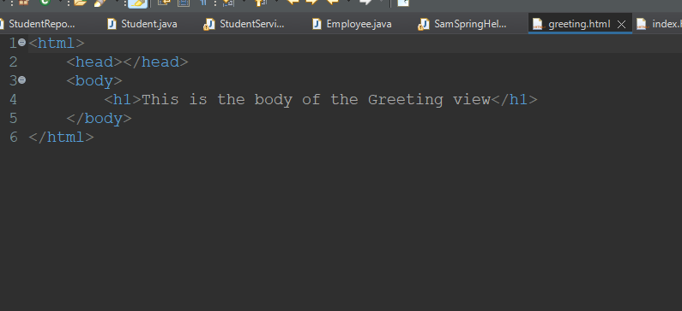

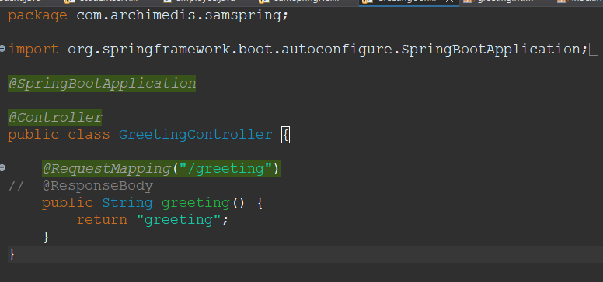

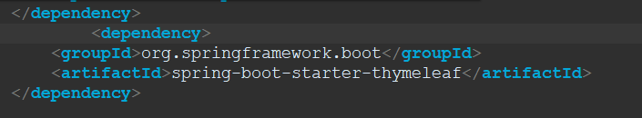

1. Using Different server combination.

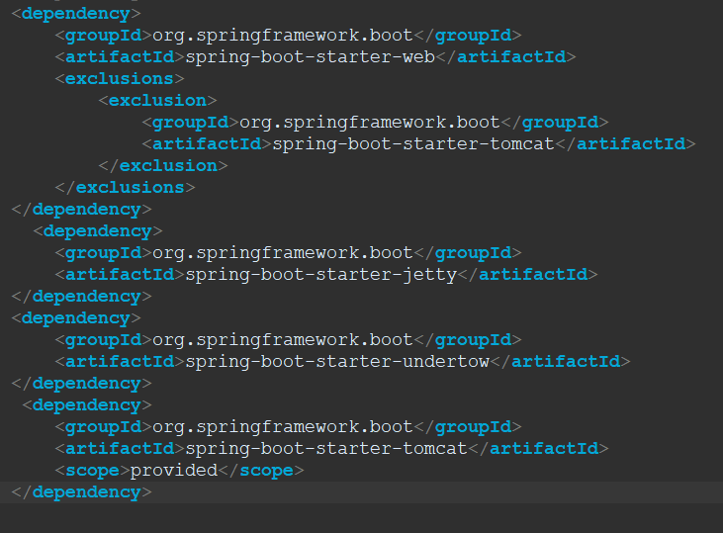

1. JSON Response and error configuration on same page.

Answ:@Controller and @ResponseBody.

1. Spring Dev Tools.

Ans: Used for Auto Compilation and Execution

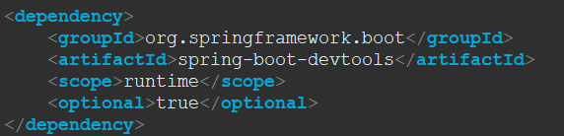

1. Spring Actuator.

Ans: Used for Quality Checking.

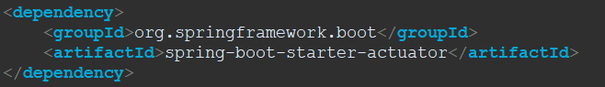

1. Spring Database Connection. 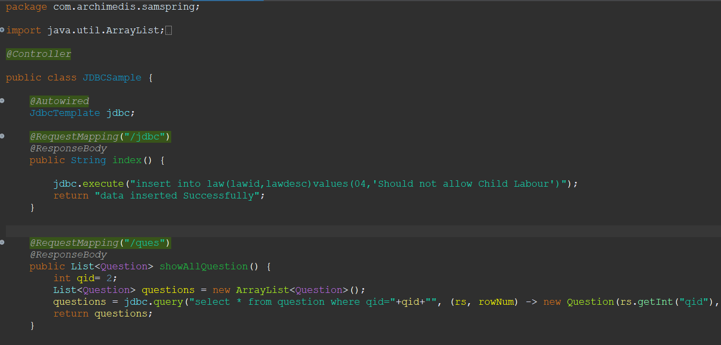
2. Spring Data JPA.
3. Spring Service and Component.
4. Spring Autowired.

Note: 12,13,14 is Used on Documentation of Java Spring Boot Application.